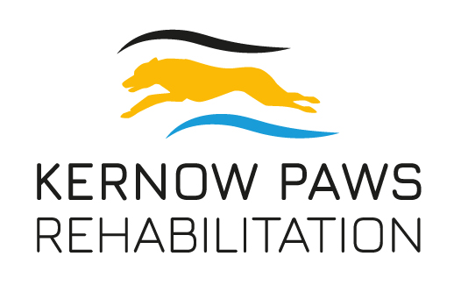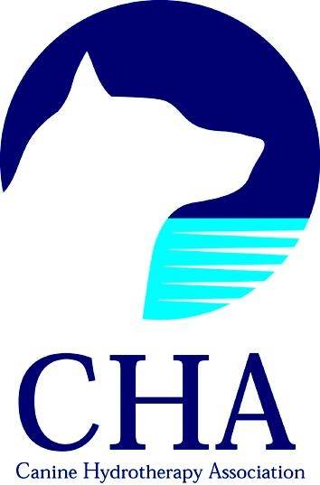

Unit 3 Camborne Business Centre,

Weeth Lane, Camborne TR14 7DB

Tel: 07807 883690

Email: kernowpaws@gmail.com

**Request for Medical Information**

**Owner details**

|  |  |
| --- | --- |
| Name |  |
| Address |  |
| Postcode |  |
| Tel No |  |

**Animal Details**

|  |  |  |  |
| --- | --- | --- | --- |
| Name |  | Vaccination Expiry |  |
| Breed |  | Insured |  |
| Colour |  | Insurance Company |  |
| Sex |  | Policy Number |  |
| Date of Birth |  | Provisional Treatment Date |  |

**\*THIS SECTION SHOULD BE COMPLETED BY THE VETERINARY SURGEON \***

|  |  |
| --- | --- |
| Veterinary Surgeon |  |
| Practice Details |  |
| Tel No/ Email |  |

|  |
| --- |
| Summary of dogs illness/injury, medications and any other comments |
| please continue overleaf |

|  |
| --- |
| Treatment/s  Hydrotherapy Y / N Physiotherapy Y / *N* Laser Therapy Y / N Massage Therapy Y / N PEMF Y / N |
| **Vet’s signature**: Print : Date: |

|  |
| --- |
| **For the Owner**: I declare that I am the legal owner of the above named dog and that the information shown on this form is correct.  Signature: Print: Date: |